**Introduction to Kinetics: Factors that Affect the Rate of Reaction**

He Wenxin何雯欣

March 27, 2019

Student ID 518370910117

Section 3

Group 3

Members Qiu Jiahao 裘嘉豪

Feng Hanyang 冯瀚扬

Xu Jiaying 许佳滢

Telephone 15921193245

Email Address wenxin_he@sjtu.edu.cn

University of Michigan-Shanghai Jiao Tong University Joint Institute(UM-SJTU JI)

# Ⅰ OBJECTIVES

* List and prove the factors affecting the rate of the reaction
* Apply the knowledge of rate-affecting factors to real scenarios
* Develop teamwork skills to combine theory and pratice

# Ⅱ INTRODUCTION

Different chemical reactions show different reaction rates. Learning how to control and what affects the rate helps us know more about the mechanism of reactions. Chemical kinetics is a field where rate is studied. Like the chemists, computer engineers and people doing other jobs are also concerned with the speed of process.

# Ⅲ BACKGROUND

We can think of the model of atoms as reference when we study the effects of concentration, surface area, temperature and catalysts.

1. **Effect of changing the Concentration of Reactions**

Molecules must collide with each other to trigger a chemical reaction. By increasing the concentration of the reactants, we can increase the opportunity for them to collide to speed up the reaction.

**B. Effect of Changing the Surface Area**

# When one of the reactants is a solid, only the atoms on the surface have the chance to collide with the other reactants. Therefore, increasing the surface area by making the solid reactants into powders can increase the number of atoms which collide with each other.

**C. Effects of Changing the Temperature**

# Although the average molecular kinetic energy of a reaction remains constant at a provided temperature, molecules need a minimum energy to react, this energy is called activation energy, Ea. Only when the energy reaches this level can a reaction start. When the temperature increases, the proportion of the atoms whose kinetic energy exceed Ea goes up. Therefore, a higher temperature allows the reaction to take place faster.

# 

# Figure 1 The relationship between temperature and the fraction of collisions with enough energy to react.

**D. Orientation of the collisions**

# Collision doesn’t ensure that the reaction will take place. Atomic orbitals must overlap in the right way. The constant ‘A’ represents the possibility of a right spatial relationship.

# Figure 2 The importance of correct spatial relationship

# E. Effect of Adding a Catalyst

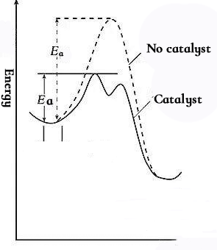

# Scientists use catalyst to speed up the reaction. A catalyst doesn’t serve as an reactant and has no change in mass in an reaction. They may temporarily donate or receive electrons to help lower the energy required.

**Figure 3** the mechanism of catalyst

# Ⅳ OVERVIEW

# A chemical reaction will be shown to demonstrate each factor affecting the rate. To understand kinetics, we should know how the changes affect different atoms and results in a change in speed.

# There’s no need to pursue accuracy since most of the experiments are qualitative.

# Ⅴ EXPERIMENTAL PROCEDURES

**Part A Effect of Changing the concentration of Reactants**

|  |  |
| --- | --- |
| Chemicals used | Materials used |
| HCl, 1M and 6M in dropper bottles Eggshells | Watch glass(2) |

Place small pieces of eggshells in each of the two watch glasses and immerse them with 6M and 1M HCl respectively. See how they react.

**Part B Effect of Changing the Surface Area**

|  |  |
| --- | --- |
| Chemicals used | Materials used |
| CuSO4, 0.2 M Iron wires & iron powder | Spatula  Disposable pipet  50 mL beakers (2)  Hot plate and thermometer  Glass stirring rods |

Add about 20mL CuSO4 solution into both two beakers and put them in hot water bath. Then add 0.2g iron powder into one beaker and 0.2g iron wire into the other beaker at the same time. Carefully stir the beakers and record color changes and how long it takes.

**Part C Effect of Changing the Temperature**

|  |  |
| --- | --- |
| Chemicals used | Materials used |
| CuSO4 (0.2 M)  Ice  Iron metal (powder) | 50-mL Glass beakers (2)  Hot plate and thermometer  Tongs or heat resistant gloves  Spatula, graduated cylinder  Clay, small lump |

Add about 20mL CuSO4 into both the two beakers Put one beaker in ice bath and the other one in hot water bath. Then add the same amount of iron powder into the solutions at the same time. Record color changes and the time it takes.

Dispose the waste according to instructor’s direction.

**Part E Effect of Adding a Catalyst.**

|  |  |
| --- | --- |
| Chemicals used | Materials used |
| Hydrogen peroxide (H2O2), 6% solution  MnO2  Ice  Iodine solution (saturated) in dropper bottles | 100-mL beaker  Hot plate and thermometer  Tongs or heat resistance gloves  600-mL beaker  Spatula  50-mL beaker  Glass stirring rods |

Add 10 mL of 6% H2O2 to a 100mL beaker. Then add 0.05g MnO2 into the solution. Record your observations within 30-45 seconds. Do not view from above, as minor splashing may occur. Finally, put the beaker in the ice bath and record your observations.

**Ⅵ CALCULATION/ANALYSIS/DATA PROCESSING**

**Part A Effect of Changing the concentration of Reactants**

As is shown in figure 4, the bubbles existed earlier on the surface of eggshells immersed in 6M HCl.

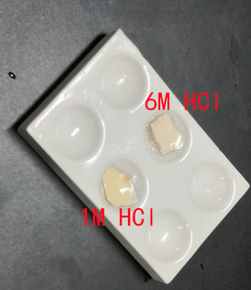**Figure 4** eggshells reacting with HCl

The eggshells on the upper side reacted with HCl with larger concentration, so it was supposed to react faster.

**Part B Effect of Changing the Surface Area**

We put two beakers with CuSO4 solution in 80℃ water bath. We added 0.2g iron wire and 0.2g iron powder into the solution respectively. After 30 seconds, the solution with iron powder in it changed from blue to green. However, the color of the other solution hadn’t changed yet.

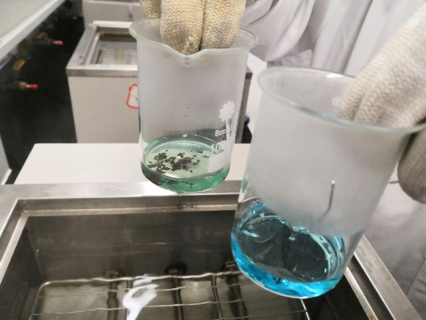

**Figure 5** CuSO4 reacting with iron powder and iron wire respectively

As the iron powder had a larger surface area, it contacted with CuSO4 more so that the reaction was faster. Fe+CuSO4 → FeSO4 +Cu. The produced is green and the blue was consumed so that the color of the solution turned green. The green color might also resulted from the combination of blue and yellow. The yellow color might come from which was produced by reacting with oxygen.

**Part C Effect of Changing the Temperature**

We put iron powder in both beakers. However, one beaker was put in the hot water bath of 80℃ while the other one was put in the ice bath. After 30 seconds, the solution in the hot water bath changes from blue to green while the water bath beaker hadn’t shown any change.

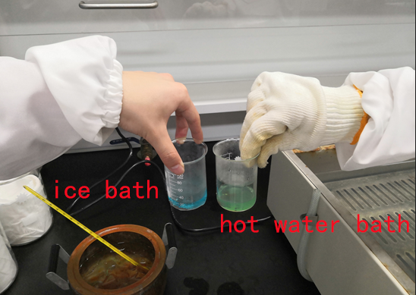

**Figure 6** Effect of changing temperature

According to theory, the higher the temperature, the faster the rate.

**Part E Effect of Adding a Catalyst**

After adding MnO2, there immediately existed lots of bubbles and the temperature of the beaker rose. After 45 seconds, we put the beaker in the ice bath, and the rate of bubbles slowed down. Finally, there were only small amounts of bubbles.

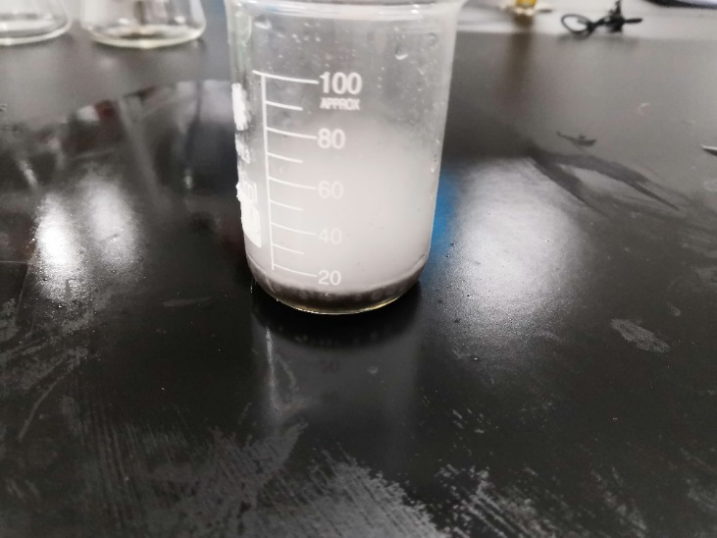

**Figure 7** H2O2 after added with MnO2

MnO2 acted as a catalyst and enhanced the speed of the reaction with no changes of itself.

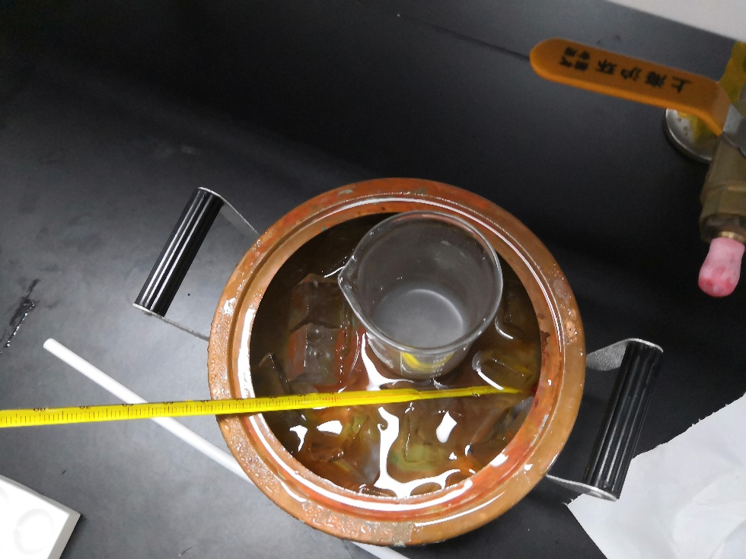

**Figure 8** H2O2 after put into ice bath

**Ⅶ DISCUSSION**

In Part A, as the experiment was designed to study the effect of changing the concentration of the reactant, the surface area of reactants should not change. However, we cannot decide whether the surface area of the eggshells were exactly the same. The experiment was not strictly conducted.

In Part B&C, we stopped our observation as soon as one of the solutions changed color. However, as time passes there may be other changes. We should have waited for a longer time and see what the two solutions look like eventually. What’s more, the iron used might rust, with oxide on its surface which cannot react with CuSO4. This might affect the experiment.

In Part E, we don’t quite understand the procedure of cooling the solution down in ice bath. Since the temperature went down, the reaction was supposed to slow down, too. It was not sufficient to prove that temperature had any effect on the catalyst.

**Ⅷ CONCLUSIONS ＆ RECOMMENDATIONS**

From the experiment, we’ve tested the four factors affecting the rate.

In Part A, the higher the concentration is, the faster the rate is.

In Part B, the larger the surface area is, the faster the rate is.

In Part C, the higher the temperature is, the faster the rate is.

In Part E, after adding catalyst, the rate rises.

We strongly recommend the experimenters to pay attention to steadying the beakers which are put in hot water bath. After putting the beaker into the hot water bath for the first time, the beaker couldn’t stand still and felled down because of buoyancy. The solution was dumped into the hot water. Therefore, the concentration of the CuSO4 solution changed and we had to prepare the solution again.

**Ⅸ REFERENCES**

-1. Peter Atkins, *Chemical Principles The Quest for Insight Seventh Edition*, Macmillan education, 2016.

-2. VC211 Laboratory Manual, UM-SJTU JI &SJTU Chemistry Department, 2018-2019.